/* Assignment Task-1:
Write a C++ code that takes an integer n as an input from the user which is greater than 5 else print
Incorrect Input! If n multiple of 5 then take a variable temp = n/2 and print temp times n else take a
variable temp = n/3 and print temp times n.*/

#include<iostream>
int main()
{
int n, temp, count = 0;
std::cout << "Enter Number =\t";
std::cin >> n;

if (n < 5)
{
std::cout << "Invalid Input...!!!" << std::endl;
}
else if (n % 5 == 0)
{
temp = n / 2;
while (count < temp)
{
std::cout << n;
count++;
}
}
else
{
temp = n / 3;
while (count < temp)
{
std::cout << n;
count++;
}
}
}
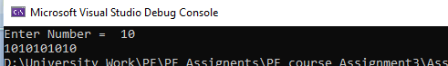

/*Assignment Task_2 :
Write a C++ program that takes an integer type variables from the user and output the following
things;
1. Count the number of digits in that number
2. Reverse this number and store back into the original variable.*/

#include<iostream>
int main()
{
int num, r = 0, temp = 0, count = 0, digit = 0, reverse = 0;
std::cout << "Enter Number =\t";
std::cin >> num;
temp = num;
while (num > 0)
{
r = num % 10;
digit = digit + 1;
num = num / 10;
}
std::cout << "Number of Digits are =\t" << digit << std::endl;
num = temp;
while (count < digit)
{
r = num % 10;
num = num / 10;
reverse = reverse * 10 + r;
count++;
}
num = reverse;
std::cout << "Reverse of Number =\t" << num << std::endl;

}
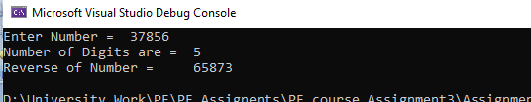

/*Assignment Task_3 :
Write a C++ code that inputs an integer number of any length from user and print it into words.*/

#include<iostream>
int main()
{
int num , rem = 0, reverse = 0;
std::cout << "Enter an Integer Number =\t";
std::cin >> num;

while (num != 0)
{
rem = num % 10;
num = num / 10;
reverse = reverse * 10 + rem;
}
num = reverse;
while (num != 0)
{
rem = num % 10;
switch (rem)
{
case 1:
std::cout << " One ";
break;
case 2:
std::cout << " Two ";
break;
case 3:
std::cout << " Three ";
break;
case 4:
std::cout << " Four ";
break;
case 5:
std::cout << " Five ";
break;
case 6:
std::cout << " Six ";
break;
case 7:
std::cout << " Seven ";
break;
case 8:
std::cout << " Eight ";
break;
case 9:
std::cout << " Nine ";
break;
}

num = num / 10;
}

}
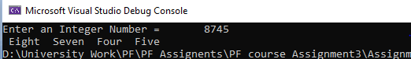

/* Assignment Task 4:
Write a C++ program to prompt user to enter month and year. Your program should display the
number of days in the month of that year.*/

#include<iostream>
int main()
{
int month, year;

std::cout << "Enter Month Number :\t";
std::cin >> month;

std::cout << "Enter Year :\t";
std::cin >> year;

switch (month)
{
case 1:
std::cout << "Number of Days in this Month = 31 Days";
break;
case 2:
switch (year % 4)
{
case 0:
std::cout << "Number of Days in Month = 29 Days";
break;
default:
std::cout << "Number of Days in Month = 28 Days";
break;
}
break;
case 3:
std::cout << "Number of Days in this Month = 31 Days";
break;
case 4:
std::cout << "Number of Days in this Month = 30 Days";
break;
case 5:
std::cout << "Number of Days in this Month = 31 Days";
break;
case 6:
std::cout << "Number of Days in this Month = 30 Days";
break;
case 7:
std::cout << "Number of Days in this Month = 31 Days";
break;
case 8:
std::cout << "Number of Days in this Month = 31 Days";
break;
case 9:
std::cout << "Number of Days in this Month = 30 Days";
break;
case 10:
std::cout << "Number of Days in this Month = 31 Days";
break;
case 11:
std::cout << "Number of Days in this Month = 30 Days";
break;
case 12:
std::cout << "Number of Days in this Month = 31 Days";
break;
default:
std::cout << "Incorrect Month !";
break;
}

std::cout << std::endl << std::endl;
system("pause");
system("CLS");

}
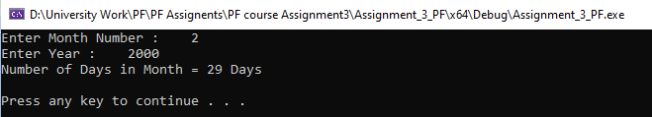

/*Task_05:
Write a C++ code that takes a binary input from the user and contains more than six and less than ten
digits and counts the total 1’s present in it. If the digits are less than six it will print Digits are less
than six and if the digits are greater than 10 it will print Digits are greater than 10. In case if the
user has entered a number that is not a binary number than it will print Incorrect Input! It is not a
Binary Number.*/

#include<iostream>
int main()
{
int num , rem = 0 ,digitcount = 0, oncecount = 0;
std::cout << "Enter Binary Number :\t";
std::cin >> num;
while (num != 0)
{
rem = num % 10;
digitcount = digitcount + 1;
num = num / 10;

if (rem == 1)
{
oncecount = oncecount + 1;
}
if (rem > 1)
{
std::cout << "Number is not binary...plss..Enter Binary Number"<<std::endl;
break;
}

}
if (digitcount > 6 && digitcount < 10)
{
std::cout << "Digits are greater than 6 and less than 10" << std::endl;
std::cout << "number of ones = \t" << oncecount << std::endl;

}
else if (digitcount < 6)
{
std::cout << "Digits are less than 6 !" << std::endl;
}
else if (digitcount > 10)
{
std::cout << "Digits are greater than 10 !" << std::endl;
}

system("pause");
}
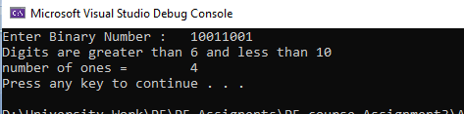

/*Assignment_Task_6:
In this question, find the Sum of following exponential series up to N terms. Ask the user to input N
and X from the console. You are not allowed to use any built-in, library or custom-made functions.*/
#include<iostream>
#include<conio.h>
int main()
{
float p = 0,power=1,c=0,n,x,fact=1,sumfact=0;
std::cout << "Enter Nth Term of Series =\t";
std::cin >> n;
std::cout << "Enter Value of X =\t";
std::cin >> x;

std::cout << "Sum = ";
while (p <= n)
{

power = 1;
c = 0;
while (c < p)
{
power = power * x;
c++;
}

c = 1;
fact = 1;
while (c <= p)
{
fact = fact * c;
c++;

}
sumfact = sumfact + fact;
if(p!=0)
std::cout << " + ";
std::cout << power / sumfact;

p++;

}
std::cout << std::endl;
std::cout << std::endl;
_getch();
system("paused");

}
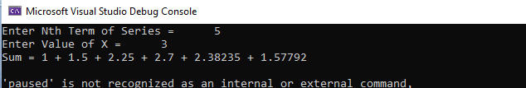

/* Task_07:
Write a C++ Program that is using a sentinel control while loop statement and if statement to
write a program that can be used at a department store’s register the records the number of customers
who spent between $0.00-$200.00, and the number of customers who spent between $200.01-$800.01
and the number of customers who spent $800.01 or more. At the end of the day, the program will print
out the number of customers in each of categories and total spending in each categories.*/
#include<iostream>
int main()
{
float spending, tspending1=0,tspending2=0,tspending3=0;
int count1=0,count2=0, count3=0;
int option;
while(1)
{
std::cout << "Pls Enter Customer's spending :\t";
std::cin >> spending;
if (spending > 0.00 && spending <= 200.00)
{
count1 = count1 + 1;
tspending1 = tspending1 + spending;
}
else if (spending >= 200.01 && spending <= 800.01)
{
count2 = count2 + 1;
tspending2 = tspending2 + spending;
}
else if (spending >= 800.01)
{
count3 = count3 + 1;
tspending3 = tspending3 + spending;
}
std::cout << std::endl;
std::cout << "---------------------------------------------------------------";
std::cout << std::endl;
std::cout << "Wants to continue the program ?" << std::endl<<"Enter 0 for Yes and any other Number for No"<<std::endl;
std::cin >> option;
if (option != 0)
{
break;
}

}
std::cout << std::endl;
std::cout << "The Total Number Of customers with their spendings between 0.00$ ~ 200.0$ =\t" << count1 << std::endl;
std::cout << "The Total Number Of customers with their spendings between 200.01.00$ ~ 800.01$ =\t" << count2 << std::endl;
std::cout << "The Total Number Of customers with their spendings more than 800.01$ =\t" << count3 << std::endl;
std::cout << "Total Spendings between 0.00$~200.0$ =\t" << tspending1<< std::endl;
std::cout << "Total Spendings between 200.01$~800.1$ =\t" << tspending2<< std::endl;
std::cout << "Total Spendings more than 800.01$ =\t" << tspending1<< std::endl;

}
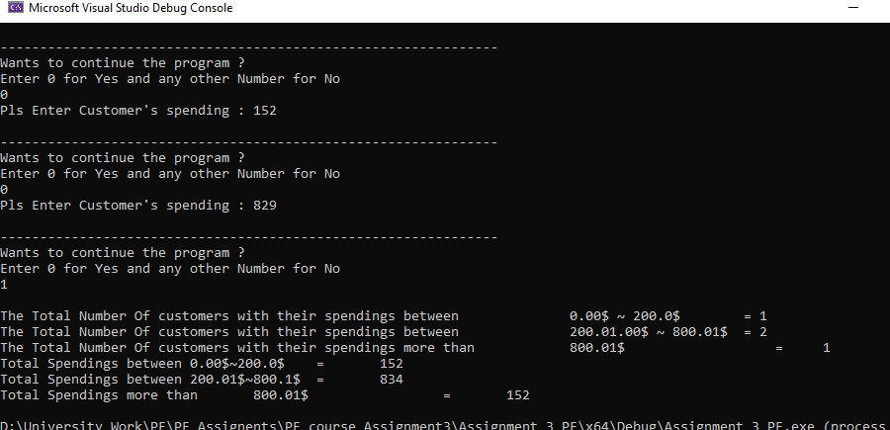

/* Assignment_Task_8:
An organization wanted to give bonus to his employees in three situations
a) For either gender, if age is more than 30 and basic pay is more than 25000 then bonus is
25% of basic pay
b) For male, if age is less than 30, and basic pay is more than 21000 then bonus is 17% of
basic pay
c) For female employees, if age is less than 25, and basic pay is more than 18000 then bonus is
13% of basic pay
In any other condition organization will not give bonus.
Use sentinel controlled while loop to input the employees data from user. Whenever user enters, -
999 then stop your program!*/

#include<iostream>
int main()
{
int age, basicpay,userinput=1;
float bonus=0;
char gender;
while (1)
{
std::cout << "Enter basic Pay =\t";
std::cin >> basicpay;
std::cout << "Enter age =\t";
std::cin >> age;
std::cout << "Enter gender =\t";
std::cin >> gender;

if (age > 30 && basicpay > 25000)
{
bonus = 0.25 * basicpay;
std::cout << "Your Bonus is =\t" << bonus << std::endl;
}

else if (gender == 'M' || gender == 'm'&& age < 30 && basicpay>21000)
{
bonus = 0.17 * basicpay;
std::cout << "Your Bonus is =\t" << bonus << std::endl;
}

else if (gender == 'F' || gender == 'f' && age < 25 && basicpay>18000)
{
bonus = 0.13 * basicpay;
std::cout << "Your Bonus is =\t" << bonus << std::endl;
}

else
{
std::cout << "Not eligible for bonus"<< std::endl;
}

std::cout << "-----------------------------------------------------" << std::endl;

std::cout << "Enter 999 to terminate program..!!..\t"<<"\n\t\t = ";
std::cin >> userinput;
if (userinput == 999)
{
break;
}
}

system("pause");

}
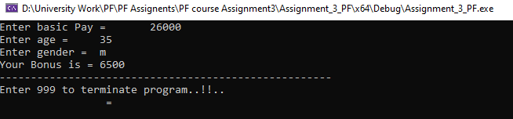

/*Task-9* : SNAKE & LEDDER GAME /
#include<iostream>
#include<cstdlib>
#include<iomanip>
#include<conio.h>
#include<ctime>
int main()
{
int destination = 1, snakes = 5, ladders = 7, dice, option, machineScore = 0, player1Score = 0, player2Score = 0, score = 0, lastPosition = 0, currentPosition = 0;
std::cout << std::setw(1500) << "MAIN MENU" << std:: endl;
std::cout << std::setw(65) << "SNAKE AND LADDER" << std::endl;
std::cout << std::endl;

std::cout << std::setw(65) << "CREDITS : CREATED BY MUHAMMAD QASIM NAVEED" << std::endl;
std::cout << std::setw(65) << "INSTRUCTIONS : " << std::endl;
std::cout << std::setw(65) << "Press 1~6 to roll dice" << std::endl;

std::cout << std::setw(65) << "PLAY GAME" << std::endl;
std::cout << std::setw(65) << "PRESS 1 FOR PLAYER VS PLAYER" << std::endl;
std::cout << std::setw(65) << "PRESS 2 FOR PLAYER VS MACHINE" << std::endl << "\t\t=";
std::cin >> option;
std::cout << std::endl;

std::cout << " Press Enter button to continue !"<< std::endl;

_getch();

if (option == 2)
{
system("CLS");
srand(time(0));
while (currentPosition <= 100)
{

dice = rand() % 6 + 1;
std::cout << "Number on Dice of Machine =\t" << dice << std::endl;
machineScore = score + dice;
score = machineScore;
currentPosition = machineScore;

//Ladders
if (score == 1)
{
currentPosition = 38;
score = currentPosition;
std::cout << "going up the ladder and now \t ";
}
else if (score == 4)
{
currentPosition = 14;
score = currentPosition;
std::cout << "going up the ladder and now \t ";
}
else if (score == 21)
{
currentPosition = 42;
score = currentPosition;
std::cout << "going up the ladder and now \t ";
}
else if (score == 28)
{
currentPosition = 84;
score = currentPosition;
std::cout << "going up the ladder and now \t ";
}
else if (score == 51)
{
currentPosition = 67;
score = currentPosition;
std::cout << "going up the ladder and now \t ";
}
else if (score == 72)
{
currentPosition = 91;
score = currentPosition;
std::cout << "going up the ladder and now \t ";
}
else if (score == 80)
{
currentPosition = 99;
score = currentPosition;
std::cout << "going up the ladder and now \t ";
}

//Snakes
if (score == 17)
{
currentPosition = 7;
score = currentPosition;
std::cout << "Oops! There is a Snake and now \t";
}
else if (score == 62)
{
currentPosition = 19;
score = currentPosition;
std::cout << "Oops! There is a Snake and now \t";
}
else if (score == 54)
{
currentPosition = 34;
score = currentPosition;
std::cout << "Oops! There is a Snake and now \t";
}
else if (score == 87)
{
currentPosition = 36;
score = currentPosition;
std::cout << "Oops! There is a Snake and now \t";
}
else if (score == 98)
{
currentPosition = 79;
score = currentPosition;
std::cout << "Oops! There is a Snake and now \t";
}

if (currentPosition > 100)
{
currentPosition = currentPosition - dice;
score = currentPosition;
}
std::cout << "Current position of Machine =\t" << currentPosition << std::endl << std::endl;
std::cout << "Score of Machine =\t" << score << std::endl << std::endl;

if (currentPosition == 100)
{
std::cout << "Hurrah!!!..Machine wins !..." << std::endl;
break;
}

dice = rand() % 6 + 1;
std::cout << "Number on Player 1 dice =\t" << dice << std::endl;
player1Score = score + dice;
score = player1Score;
currentPosition = player1Score;

//Ladders
if (score == 1)
{
currentPosition = 38;
score = currentPosition;
std::cout << "going up the ladder and now \t ";
}
else if (score == 4)
{
currentPosition = 14;
score = currentPosition;
std::cout << "going up the ladder and now \t ";
}
else if (score == 21)
{
currentPosition = 42;
score = currentPosition;
std::cout << "going up the ladder and now \t ";
}
else if (score == 28)
{
currentPosition = 84;
score = currentPosition;
std::cout << "going up the ladder and now \t ";
}
else if (score == 51)
{
currentPosition = 67;
score = currentPosition;
std::cout << "going up the ladder and now \t ";
}
else if (score == 72)
{
currentPosition = 91;
score = currentPosition;
std::cout << "going up the ladder and now \t ";
}
else if (score == 80)
{
currentPosition = 99;
score = currentPosition;
std::cout << "going up the ladder and now \t ";
}

//Snakes
if (score == 17)
{
currentPosition = 7;
score = currentPosition;
std::cout << "Oops! There is a Snake and now \t";
}
else if (score == 62)
{
currentPosition = 19;
score = currentPosition;
std::cout << "Oops! There is a Snake and now \t";
}
else if (score == 54)
{
currentPosition = 34;
score = currentPosition;
std::cout << "Oops! There is a Snake and now \t";
}
else if (score == 87)
{
currentPosition = 36;
score = currentPosition;
std::cout << "Oops! There is a Snake and now \t";
}
else if (score == 98)
{
currentPosition = 79;
score = currentPosition;
std::cout << "Oops! There is a Snake and now \t";
}

std::cout << "Current position of Player 1 =\t" << currentPosition << std::endl << std::endl;
if (currentPosition > 100)
{
currentPosition = currentPosition - dice;
score = currentPosition;
}
std::cout << "Current position of Player 1 =\t" << currentPosition << std::endl << std::endl;
std::cout << "Score of Player1 =\t" << score << std::endl << std::endl;

if (currentPosition == 100)
{
std::cout << "Hurrah!!!.. Player1 wins !..." << std::endl;
break;
}

}

}

else if (option == 1)
{
system("CLS");
srand(time(0));
while (currentPosition <= 100)
{

dice = rand() % 6 + 1;
std::cout << "Number on Dice of Player 1 =\t" << dice << std::endl;
player1Score = score + dice;
score = player1Score;
currentPosition = player1Score;

//Ladders
if (score == 1)
{
currentPosition = 38;
score = currentPosition;
std::cout << "going up the ladder and now \t ";
}
else if (score == 4)
{
currentPosition = 14;
score = currentPosition;
std::cout << "going up the ladder and now \t ";
}
else if (score == 21)
{
currentPosition = 42;
score = currentPosition;
std::cout << "going up the ladder and now \t ";
}
else if (score == 28)
{
currentPosition = 84;
score = currentPosition;
std::cout << "going up the ladder and now \t ";
}
else if (score == 51)
{
currentPosition = 67;
score = currentPosition;
std::cout << "going up the ladder and now \t ";
}
else if (score == 72)
{
currentPosition = 91;
score = currentPosition;
std::cout << "going up the ladder and now \t ";
}
else if (score == 80)
{
currentPosition = 99;
score = currentPosition;
std::cout << "going up the ladder and now \t ";
}

//Snakes
if (score == 17)
{
currentPosition = 7;
score = currentPosition;
std::cout << "Oops! There is a Snake and now \t";
}
else if (score == 62)
{
currentPosition = 19;
score = currentPosition;
std::cout << "Oops! There is a Snake and now \t";
}
else if (score == 54)
{
currentPosition = 34;
score = currentPosition;
std::cout << "Oops! There is a Snake and now \t";
}
else if (score == 87)
{
currentPosition = 36;
score = currentPosition;
std::cout << "Oops! There is a Snake and now \t";
}
else if (score == 98)
{
currentPosition = 79;
score = currentPosition;
std::cout << "Oops! There is a Snake and now \t";
}

if (currentPosition > 100)
{
currentPosition = currentPosition - dice;
score = currentPosition;
}
std::cout << "Current position of player1 =\t" << currentPosition << std::endl << std::endl;
std::cout << "Score of player1 =\t" << score << std::endl << std::endl;

if (currentPosition == 100)
{
std::cout << "Hurrah!!!..Player1 wins !..." << std::endl;
break;
}

dice = rand() % 6 + 1;
std::cout << "Number on Player 2 dice =\t" << dice << std::endl;
player2Score = score + dice;
score = player2Score;
currentPosition = player2Score;

//Ladders
if (score == 1)
{
currentPosition = 38;
score = currentPosition;
std::cout << "going up the ladder and now \t ";
}
else if (score == 4)
{
currentPosition = 14;
score = currentPosition;
std::cout << "going up the ladder and now \t ";
}
else if (score == 21)
{
currentPosition = 42;
score = currentPosition;
std::cout << "going up the ladder and now \t ";
}
else if (score == 28)
{
currentPosition = 84;
score = currentPosition;
std::cout << "going up the ladder and now \t ";
}
else if (score == 51)
{
currentPosition = 67;
score = currentPosition;
std::cout << "going up the ladder and now \t ";
}
else if (score == 72)
{
currentPosition = 91;
score = currentPosition;
std::cout << "going up the ladder and now \t ";
}
else if (score == 80)
{
currentPosition = 99;
score = currentPosition;
std::cout << "going up the ladder and now \t ";
}

//Snakes
if (score == 17)
{
currentPosition = 7;
score = currentPosition;
std::cout << "Oops! There is a Snake and now \t";
}
else if (score == 62)
{
currentPosition = 19;
score = currentPosition;
std::cout << "Oops! There is a Snake and now \t";
}
else if (score == 54)
{
currentPosition = 34;
score = currentPosition;
std::cout << "Oops! There is a Snake and now \t";
}
else if (score == 87)
{
currentPosition = 36;
score = currentPosition;
std::cout << "Oops! There is a Snake and now \t";
}
else if (score == 98)
{
currentPosition = 79;
score = currentPosition;
std::cout << "Oops! There is a Snake and now \t";
}

std::cout << "Current position of Player 1 =\t" << currentPosition << std::endl << std::endl;
if (currentPosition > 100)
{
currentPosition = currentPosition - dice;
score = currentPosition;
}
std::cout << "Current position of Player 2 =\t" << currentPosition << std::endl << std::endl;
std::cout << "Score of Player2 =\t" << score << std::endl << std::endl;

if (currentPosition == 100)
{
std::cout << "Hurrah!!!.. Player2 wins !..." << std::endl;
break;
}

}
}
else
std::cout << " Wrong Input ! " << std::endl<< std::endl;

system("pause");
}
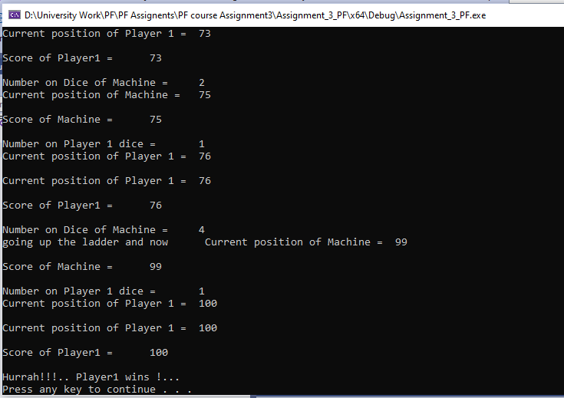

/*Task-10 : TIC-TAC-TOE GAME*/

#include<iostream>
#include<cstdlib>
#include<iomanip>
#include<conio.h>
#include<ctime>;
int main()
{
int filledcounter=0;
char b1 = '1', b2 = '2', b3 = '3', b4 = '4', b5 = '5', b6 = '6', b7 = '7', b8 = '8', b9 = '9';
char keypress;
int playerturn;
bool toss,flag=true;

std::cout << std::setw(1500) << "MAIN MENU" << std::endl;
std::cout << std::setw(65) << "TIC-TAC-TOE" << std::endl;
std::cout << std::endl;

std::cout << std::setw(65) << "CREDITS : CREATED BY MUHAMMAD QASIM NAVEED" << std::endl;
std::cout << std::setw(65) << "INSTRUCTIONS : " << std::endl;
std::cout << std::setw(65) << "\t\t\t1_win by entering same symbols in a row (up, down, across, or diagonally) " << std::endl;
std::cout << std::setw(65) << "\t\t\t2_When all 9 squares are full, the game is over " << std::endl;
std::cout << std::setw(65) << "\t\t\t If no player has 3 marks in a row, the game ends in a tie." << std::endl;

std::cout << std::setw(65) << "PLAY GAME" << std::endl;
std::cout << std::setw(65) << "PLAYER VS PLAYER" << std::endl;

std::cout << std::endl;

std::cout << " Press Enter button to continue !" << std::endl;

_getch();
system("CLS");
std::cout << "-------------------------------------------------------------------------------------------" << std::endl;
srand(time(0));
toss = rand() % 2;
if (toss == 0)
{
playerturn = 1;
while (1)
{
system("CLS");

std::cout << "\n\n\n\n\n\n\n\n" << std::endl;
std::cout << " | |" << std::endl;
std::cout << "\t\t\t\t___" << b1 << "____|____" << b2 << "____|____" << b3 << "___ " << std::endl;
std::cout << " | |" << std::endl;
std::cout << "\t\t\t\t___" << b4 << "____|____" << b5 << "____|____" << b6 << "___ " << std::endl;
std::cout << " | |" << std::endl;
std::cout << "\t\t\t\t___" << b7 << "____|____" << b8 << "____|____" << b9 << "___ " << std::endl;
std::cout << " | |" << std::endl;

if ((b1 == b2 && b2 == b3 ) || (b4 == b5 && b5 == b6) || (b7 == b8 && b8 == b9))
{
if (playerturn == 1)
{
playerturn = 2;
std::cout << "Congrats ! ................Player " << playerturn << " wins...............!!";
flag = false;
break;
}
else
{
playerturn = 1;
std::cout << "Congrats ! ................Player " << playerturn << " wins...............!!";
flag = false;
break;
}

}
if ((b1 == b4 && b4 == b7) || (b2 == b5 && b5 == b8) || (b3 == b6 && b6 == b9))
{
if (playerturn == 1)
{
playerturn = 2;
std::cout << "Congrats ! ................Player " << playerturn << " wins...............!!";
flag = false;
break;
}
else
{
playerturn = 1;
std::cout << "Congrats ! ................Player " << playerturn << " wins...............!!";
flag = false;
break;
}

}

if ((b1 == b5 && b5 == b9) || (b3 == b5 && b5 == b7))
{
if (playerturn == 1)
{
playerturn = 2;
std::cout << "Congrats ! ................Player " << playerturn << " wins...............!!";
flag = false;
break;
}
else
{
playerturn = 1;
std::cout << "Congrats ! ................Player " << playerturn << " wins...............!!";
flag = false;
break;
}

}

std::cout << "..........Player " << playerturn << " turn......" << std::endl;
std::cout << "Enter Number of box : \t";
keypress = _getch();
if (keypress == '0')
{
break;
}

if (playerturn == 1)
{
if (b1 == '1' && keypress == '1')
{
b1 = 'X';
filledcounter++;
}

else if (b2 == '2' && keypress == '2')
{
b2 = 'X';
filledcounter++;
}

else if (b3 == '3' && keypress == '3')
{
b3 = 'X';
filledcounter++;
}

else if (b4 == '4' && keypress == '4')
{
b4 = 'X';
filledcounter++;
}

else if (b5 == '5' && keypress == '5')
{
b5 = 'X';
filledcounter++;
}

else if (b6 == '6' && keypress == '6')
{
b6 = 'X';
filledcounter++;
}

else if (b7 == '7' && keypress == '7')
{
b7 = 'X';
filledcounter++;
}

else if (b8 == '8' && keypress == '8')
{
b8 = 'X';
filledcounter++;
}

else if (b9 == '9' && keypress == '9')
{
b9 = 'X';
filledcounter++;
}
else
continue;
}
else if (playerturn == 2)
{
if (b1 == '1' && keypress == '1')
{
b1 = 'O';
filledcounter++;
}

else if (b2 == '2' && keypress == '2')
{
b2 = 'O';
filledcounter++;
}

else if (b3 == '3' && keypress == '3')
{
b3 = 'O';
filledcounter++;
}

else if (b4 == '4' && keypress == '4')
{
b4 = 'O';
filledcounter++;
}

else if (b5 == '5' && keypress == '5')
{
b5 = 'O';
filledcounter++;
}

else if (b6 == '6' && keypress == '6')
{
b6 = 'O';
filledcounter++;
}

else if (b7 == '7' && keypress == '7')
{
b7 = 'O';
filledcounter++;
}

else if (b8 == '8' && keypress == '8')
{
b8 = 'O';
filledcounter++;
}

else if (b9 == '9' && keypress == '9')
{
b9 = 'O';
filledcounter++;
}
else
continue;

}

if (playerturn == 1)
{
playerturn = 2;
}
else if(playerturn==2)
playerturn= 1;
std::cout << ".........Now Turn is of Player" << playerturn << "...................." << std::endl;

}
}
else if (toss == 1)
{
std::cout << ".....................Player 1 turn First................" << std::endl;
playerturn = 2;

while (1)
{
system("CLS");
// Board
std::cout << "\n\n\n\n\n\n\n\n" << std::endl;
std::cout << " | |" << std::endl;
std::cout << "\t\t\t\t___" << b1 << "____|____" << b2 << "____|____" << b3 << "___ " << std::endl;
std::cout << " | |" << std::endl;
std::cout << "\t\t\t\t___" << b4 << "____|____" << b5 << "____|____" << b6 << "___ " << std::endl;
std::cout << " | |" << std::endl;
std::cout << "\t\t\t\t___" << b7 << "____|____" << b8 << "____|____" << b9 << "___ " << std::endl;
std::cout << " | |" << std::endl;

if ((b1 == b2 && b2 == b3) || (b4 == b5 && b5 == b6) || (b7 == b8 && b8 == b9))
{
if (playerturn == 1)
{
playerturn = 2;
std::cout << "Congrats ! ................Player " << playerturn << " wins...............!!";
flag = false;
break;
}
else
{
playerturn = 1;
std::cout << "Congrats ! ................Player " << playerturn << " wins...............!!";
flag = false;
break;
}

}
if ((b1 == b4 && b4 == b7) || (b2 == b5 && b5 == b8) || (b3 == b6 && b6 == b9))
{
if (playerturn == 1)
{
playerturn = 2;
std::cout << "Congrats ! ................Player " << playerturn << " wins...............!!";
flag = false;
break;
}
else
{
playerturn = 1;
std::cout << "Congrats ! ................Player " << playerturn << " wins...............!!";
flag = false;
break;
}

}

if ((b1 == b5 && b5 == b9) || (b3 == b5 && b5 == b7))
{
if (playerturn == 1)
{
playerturn = 2;
std::cout << "Congrats ! ................Player " << playerturn << " wins...............!!";
flag = false;
break;
}
else
{
playerturn = 1;
std::cout << "Congrats ! ................Player " << playerturn << " wins...............!!";
flag = false;
break;
}

}

std::cout << "Player " << playerturn << " turn"<< std::endl;
std::cout << "Enter Number of box :\t";
keypress = _getch();
if (keypress == '0')
{
break;
}

if (playerturn == 1)
{
if (b1 == '1' && keypress == '1')
{
b1 = 'X';
filledcounter++;
}

else if (b2 == '2' && keypress == '2')
{
b2 = 'X';
filledcounter++;
}

else if (b3 == '3' && keypress == '3')
{
b3 = 'X';
filledcounter++;
}

else if (b4 == '4' && keypress == '4')
{
b4 = 'X';
filledcounter++;
}

else if (b5 == '5' && keypress == '5')
{
b5 = 'X';
filledcounter++;
}

else if (b6 == '6' && keypress == '6')
{
b6 = 'X';
filledcounter++;
}

else if (b7 == '7' && keypress == '7')
{
b7 = 'X';
filledcounter++;
}

else if (b8 == '8' && keypress == '8')
{
b8 = 'X';
filledcounter++;
}

else if (b9 == '9' && keypress == '9')
{
b9 = 'X';
filledcounter++;
}
else
continue;
}
else if (playerturn == 2)
{
if (b1 == '1' && keypress == '1')
{
b1 = 'O';
filledcounter++;
}

else if (b2 == '2' && keypress == '2')
{
b2 = 'O';
filledcounter++;
}

else if (b3 == '3' && keypress == '3')
{
b3 = 'O';
filledcounter++;
}

else if (b4 == '4' && keypress == '4')
{
b4 = 'O';
filledcounter++;
}

else if (b5 == '5' && keypress == '5')
{
b5 = 'O';
filledcounter++;
}

else if (b6 == '6' && keypress == '6')
{
b6 = 'O';
filledcounter++;
}

else if (b7 == '7' && keypress == '7')
{
b7 = 'O';
filledcounter++;
}

else if (b8 == '8' && keypress == '8')
{
b8 = 'O';
filledcounter++;
}

else if (b9 == '9' && keypress == '9')
{
b9 = 'O';
}
else
continue;
}

if (playerturn == 1)
{
playerturn = 2;
}
else
playerturn = 1;
}

}
std::cout << std::endl;
std::cout << std::endl;

std::cout << " \t Game End.....Press Enter to Exit...!!\t "<< std::endl;
std::cout << std::endl;
std::cout << std::endl;
_getche();
std::cout << std::endl;
system("paused");

}
